2025 Tournament Official Rules
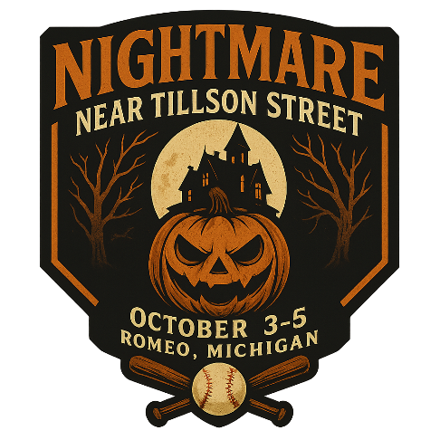

Gameplay Rules
- 14u USSSA Baseball Rules in effect unless otherwise stated
  - https://www.usssa.com/docs/baseball/usssa_bb_rules.pdf
- This is a WOOD BAT only Tournament
- Balks are called – there are no warnings
- Metal Cleats are allowed
- No new innings after 1hr 40min – an inning begun shall be played to completion
  - An inning is considered “begun” upon the final out of the previous inning
    - Final out of 4th inning is at 1:39pm – 5th inning begins at 1:39pm
  - The Umpire’s time is official
  - Home Team does not bat if ahead in the bottom of last inning
    - Either 7th inning or a time/mercy/darkness shortened game
- Game is considered complete per USSSA Rules after 4 innings, or 3½ innings if Home Team is ahead in a game shortened due to darkness, weather, or other acts of nature
- Pool Play Home/Away pre-determined by coin-flip
- Bracket Play the higher seed is the Home Team
- 7 Innings max unless shortened by time/darkness/mercy
- Championship Game will be 7 innings and no time limit with a physical Coin Flip
- Teams may bat no more than 10 total hitters (DH allowed, 1 EH allowed)
  - Changes to the lineup should be done with the opposing team prior to the substitution coming up to bat, but does not need to be cleared with the Umpire.
- Teams must have at least 8 players to avoid a forfeit
  - 9th position is an out
  - If 9th player arrives late, he may then be entered into the lineup in the 9th position to avoid the automatic out
- Free defensive substitutions at any time for any player without affecting batting lineup
- If a player is pinch-hit for he may re-enter defensively or as a courtesy runner, but is not eligible to hit again
- Courtesy Runners allowed for Pitchers and Catchers at any time
  - Last batted out, or a player from the bench at team discretion
  - Required for Catchers with 2 outs to keep games moving
- 10 Inning max per Pitcher for entire tournament
  - Umpires to track and submit to event staff after games
- Intentional Walks can be issued without throwing pitches. Just ask the umpire to put the batter on 1st
- No “quick pitching” – the batter should be alert and ready prior to the pitch being thrown. Ruled at discretion of Umpire.

Player Eligibility
- Players aged 14 and younger as of April 30, 2026 are eligible for play
  - If a team wants to age challenge they must pay a $100 cash fee to event-staff up front
    - If cash fee isn’t paid, challenge is withdrawn and play shall commence
    - Teams must prove age of suspected player within a few minutes (reasonable)
      - Just have proof with you (birth certificate)
    - If team is in violation or doesn’t have acceptable proof, all completed and future games will be scored as 10-0 forfeit losses, team will be ejected from the Tournament, all costs as forfeit. $100 cash fee is returned to protesting team.
      - Bring proof with you.
    - If team shows proof and is not in violation, play shall resume and $100 cash fee is forfeited to the event.
  - The USSSA Rules allow for older kids if they are in 8th grade – we are not honoring that rule in this tournament.
General Conduct
- Umpires are the arbiters of the game
- Balls and Strikes or any Judgement calls are up to the Umpires and not up for debate by anyone at any time
  - Umpires may issue a warning if they so choose, but are not required to
  - If chirping from fans or the dugout results in an ejection the Umpires shall eject the manager 1st, and DQ the team 2nd
    - Inform your parents behind the backstops and along fences
    - Inform your assistant coaches, and players
- If there is a rules interpretation request, Event Staff may be asked – Find Matt as last resort
  - In general though, just trust the Umpires to make these calls.
- Ejected players are also disqualified for the following game
  - Umpires to submit Team and Player # to Event Staff
  - Teams that enter a DQ’ed player into a game shall be ejected from Tournament and forfeit all costs and guarantees
- Ejected coaches are disqualified for the tournament, and must vacate tournament grounds
  - Failure to comply will result in a team disqualification and forfeit of all costs
- Fighting will not be tolerated by anyone, and will involve Police as necessary
  - If opposing players, coaches or parents are fighting, both teams will be DQ’ed and police will be involved.
- Try to keep language clean there are lots of families and kids present. No rule, just keep it clean
- Friendly banter is fine, but keep it friendly
  - We get it kids and coaches know each other. Just keep it cool.
- Don’t stall the game to get to the time limit. If stalling is determined, Umpires can and should extend the game to avoid. Let the kids decide the games.
Safety and Injury Rules
- ONE On-Deck Hitter allowed and shall be behind the batter. Must wear batting helmet.
- Players may coach 1st or 3rd Base, but must wear a batting helmet
- Players must generally try to avoid contact
  - No “taking out” the catcher, or plowing thru a defensive player
  - Fielders have a right to a batted ball even if it’s in the baseline per standard baseball rules
    - Contact with a fielder making an attempt on a batted ball shall result in the batter being out, and all runners must return to original bases per standard rules
    - Runners can circle around a fielder – the baseline is established as a direct path to the next base and 3 feet in either direction during an attempted tag
      - If no tag is attempted, there is no baseline per standard rules
      - A fake tag without the ball is ruled as obstruction
  - Intentional or malicious contact results in the offending player being out, and may result in an ejection. This will supersede all obstruction penalties.
    - May result in the batter ALSO being out at the discretion of the umpire
  - Defensive players may not block a base unless they are in possession of the ball, or in the act of fielding a batted ball. If a player blocks a base and hinders a runner, the obstruction rule is applied.
    - Runners must either slide to avoid, return to previous base, or give themselves up. If you initiate contact with a player holding the ball you are out.
    - Fielders awaiting a thrown ball must not block the base, or the obstruction rule is applied.
    - Plays at 1st where a throw pulls the First Baseman into the base line may result in obstruction
- Injured players may be substituted for with a bench player, and may not re-enter the lineup
  - If there are no available bench players, then the injured player shall be counted as an out there after
- In general, runners should slide when there is a close play to both avoid tags, but also to avoid contact. While we are employing an “avoid contact” rule, runners are not forced to slide per standard baseball rules. We do encourage it though.
Mercy and Tie Breaker Rules
- 15 runs after 3 innings, 12 after 4 innings, or 8 after 5 innings
- Tie Breaker Order is:
  - Head 2 Head
  - Runs Allowed
  - Run Differential (max 10 per game)
  - Coin Flip

